**Instructions for Using Sifty**

Below are the instructions to follow to use the Sifty

Initial Setup of Sifty

1. Ensure the stopper, slider, and drawer are placed completely inside the body of the composter flush.
2. Remove the lid and add 90 in^3 of dirt and 250 red wiggler worms (Figure 1).
3. Add food scraps and other compostable matter over the next four months.
4. After four months of use, remove the stopper from the composter and place it into the stopper holder at the front face of the composter (Figure 2 and 3).

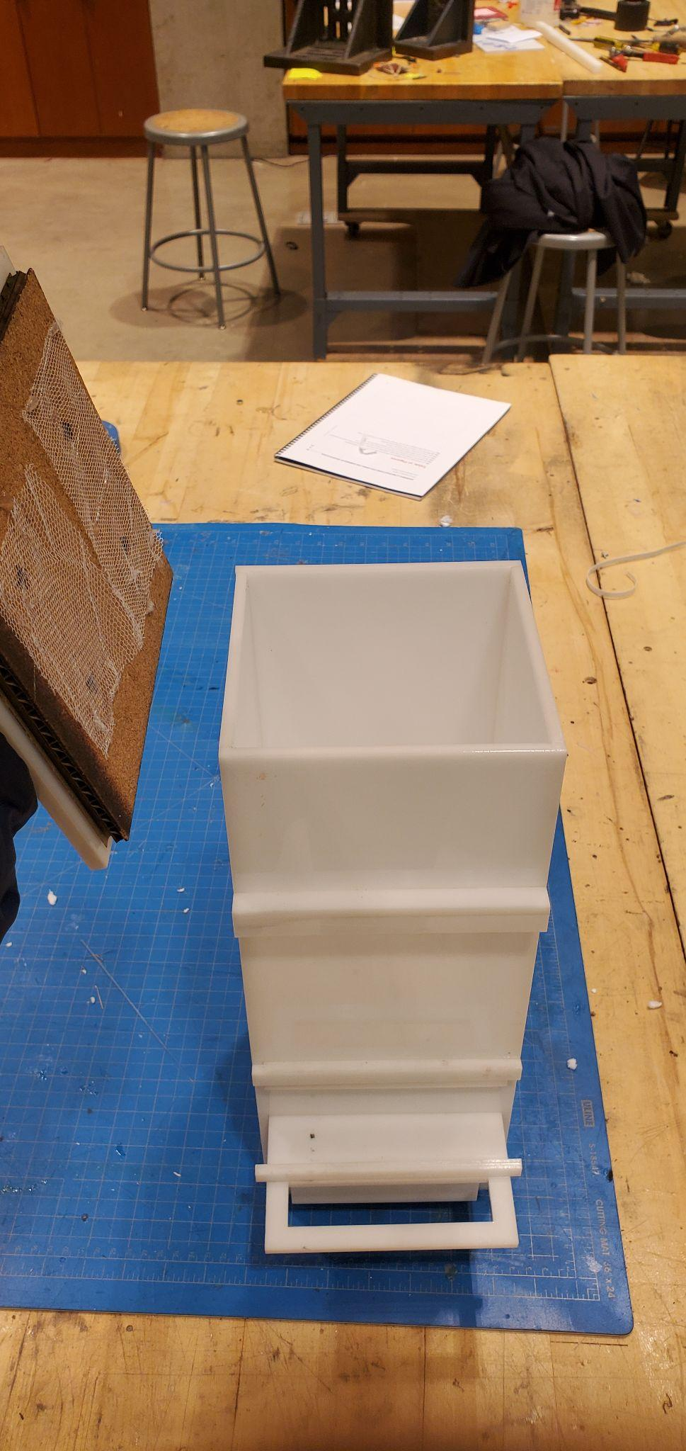 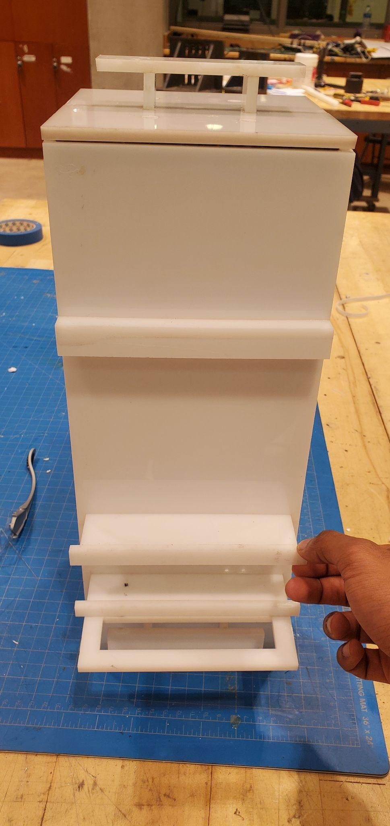 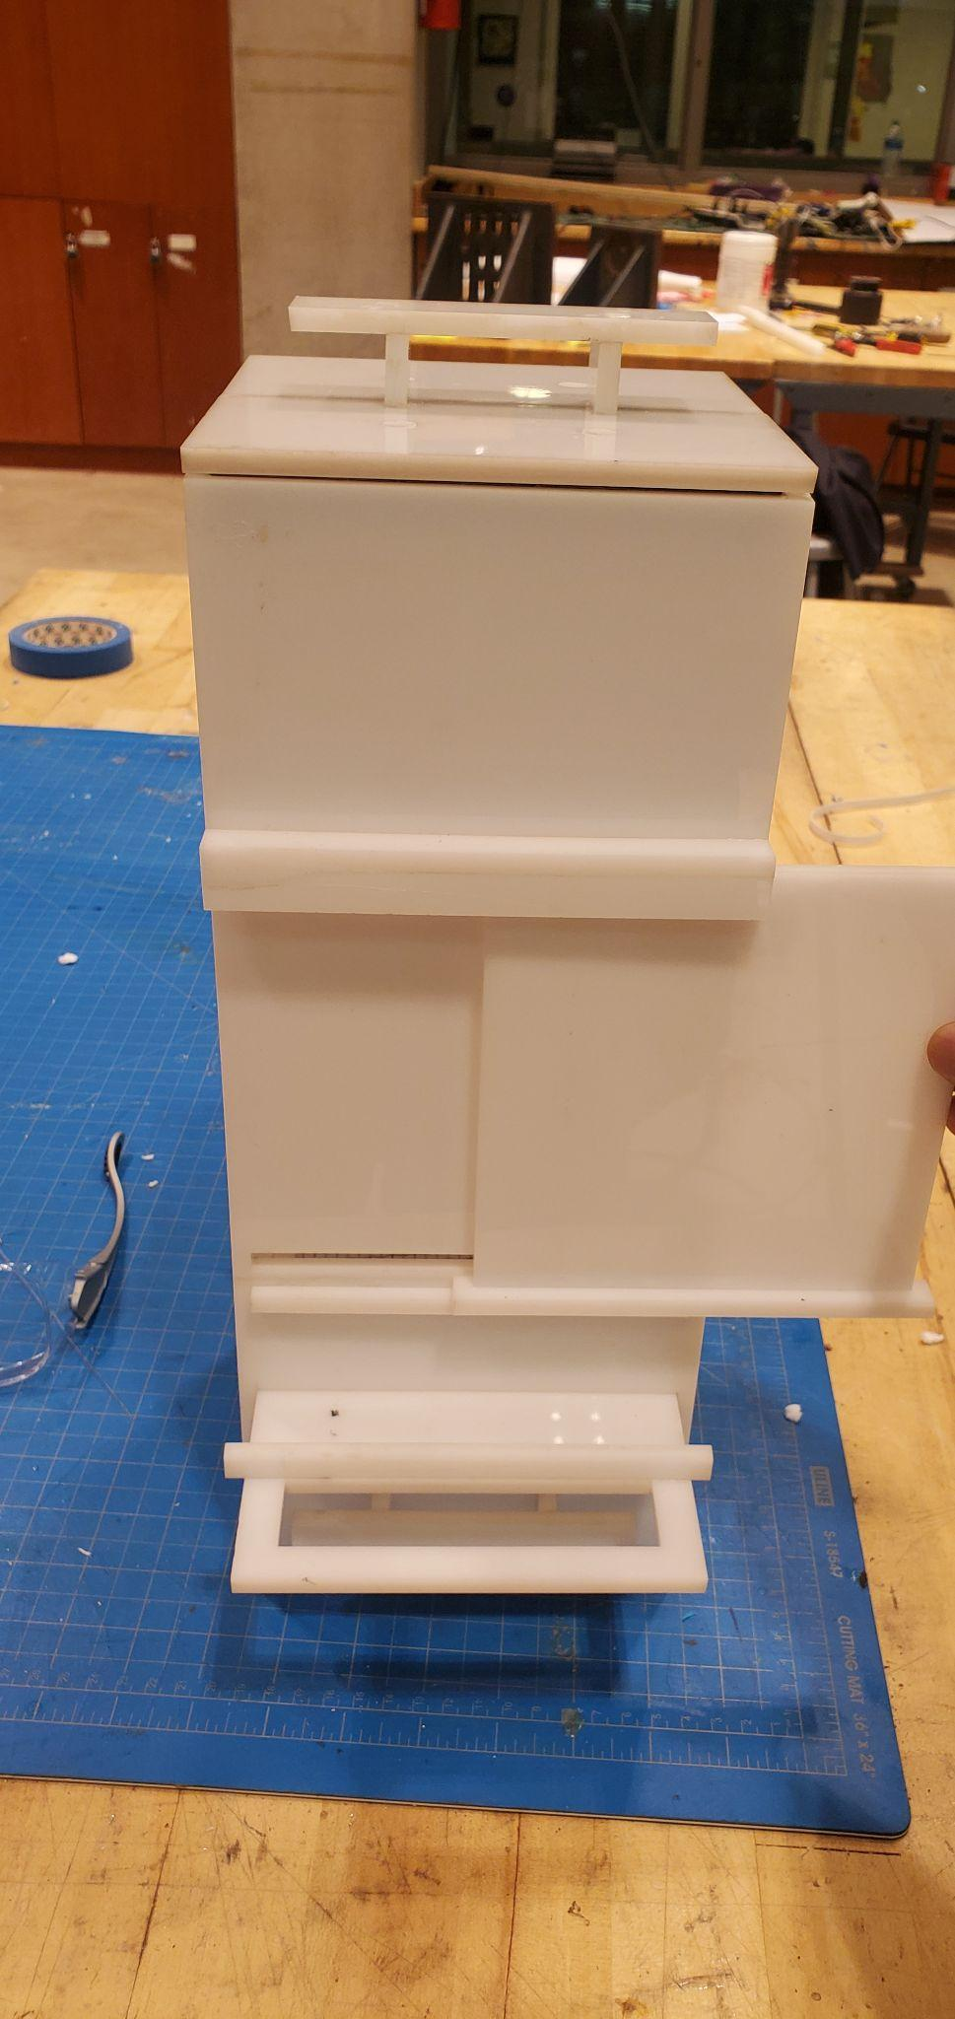

Figure 1: Open lids Figure 2: Take out stopper Figure 3: Slide stopper into

To deposit dirt and worms from stopper slit stopper holder

Sifty Is Fully Functional

1. Add food scraps as often as you wish.
2. When you want to extract worm castings, slide the filter back and forth to filter castings into the drawer (Figure 4).
3. When you want to spread worm castings to your plants, ensure there is enough castings in the drawer. If there isn’t, perform step 6. If there is, take out the drawer and spread worm castings to plants (Figure 5).

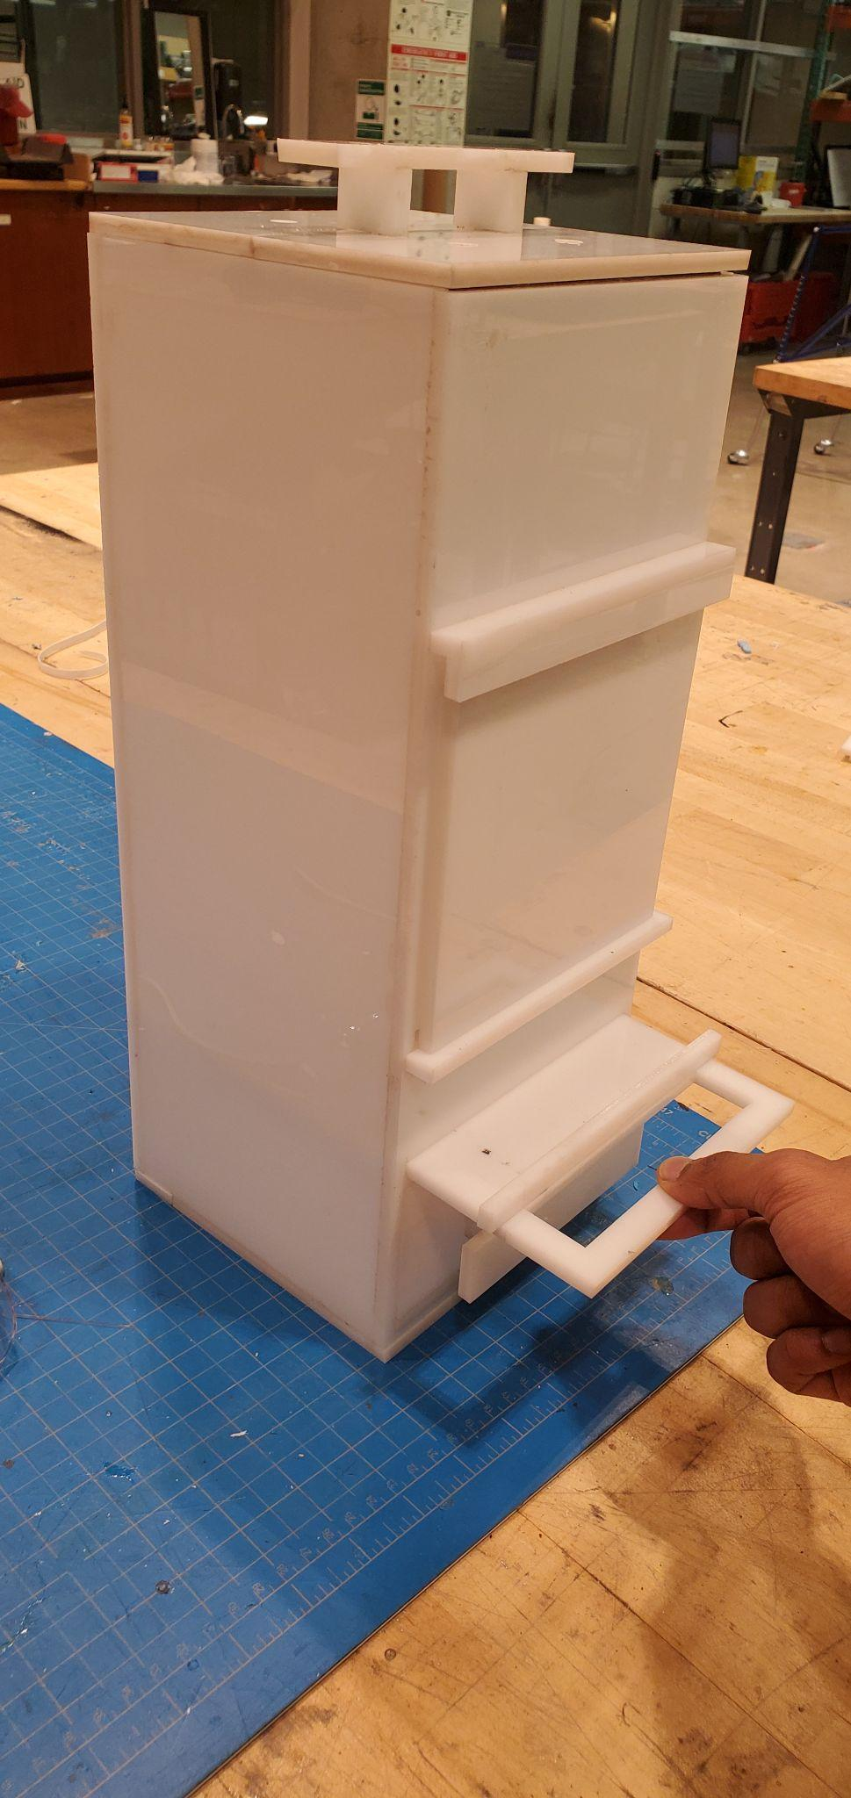 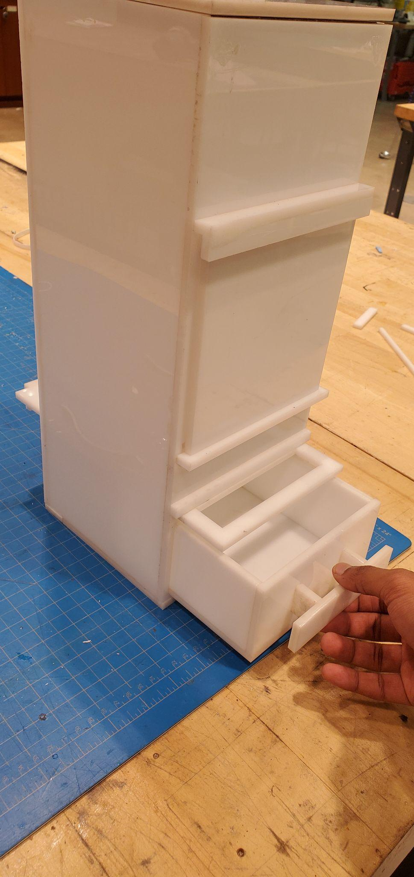

Figure 4: Slide filter back Figure 5: Take out drawer

And forth to filter castings to spread castings to plants

into drawer